DATA 468 Homework 5

Instructor: Zakir Ullah

Homework Date: May 03, 2025

Submission Date: May 10, 2025 (11:00 PM) (Beijing Time)

Submission Date in Gradescope: May 10, 2025 (8:00 AM) (Tucson Time)

**Instructions**: Please write or type your solutions clearly and show all relevant steps. Once you are done, please upload your solutions to Gradescope. Ifyou need to scan your solutions, please use a free scanning app like CamScanner instead of sending photographs. Please submit your solutions within the prescribed time, as late submissions will be notconsidered.

1. Given the following Markov Chain

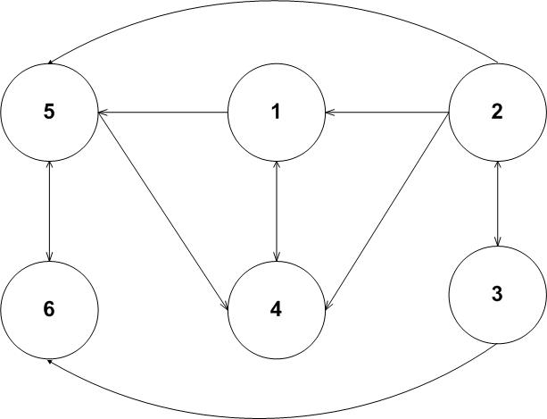



(a) Identify set of all closed sates.

(b) Identify communicating states.

(c) Identify the irreducible sates.

(e) Identify transient and recurrent sates

**Note**: Please justify your answers by explaining them in details.